📘 Titanic Survival Prediction Using Python
Name: Mohd Junaid
College: Shri Ramswaroop Memorial University
Email: junaidansari41157@gmail.com

🔹 Objective
- To analyze the Titanic dataset
- To build a model that predicts whether a passenger survived or not

🔹 Tools & Technologies
- Python
- Pandas
- Matplotlib
- Seaborn
- Scikit-learn

🔹 Dataset
- Contains passenger details like:
  - Age
  - Gender
  - Ticket Fare
  - Passenger Class
  - Survival Status

🔹 Data Cleaning
- Filled missing values in Age and Fare using mean
- Removed unnecessary columns

🔹 Feature Engineering
- Created a new feature FamilySize
- Formula: FamilySize = SibSp + Parch

🔹 Model Used
- Logistic Regression

🔹 Results
- Model accuracy: around 80%
- Most predictions are correct
- Model performs well on the dataset

🔹 Output
Confusion Matrix
- Shows correct and incorrect predictions
- Most values are correct → good performance
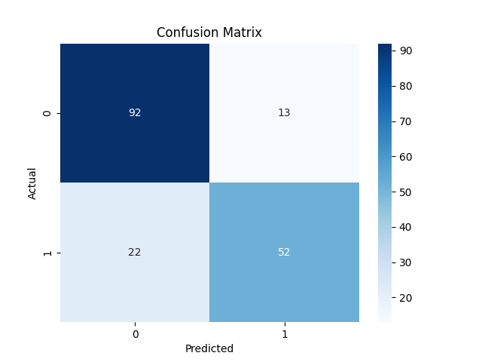

Survival Count Graph
- Displays number of survived vs not survived passengers
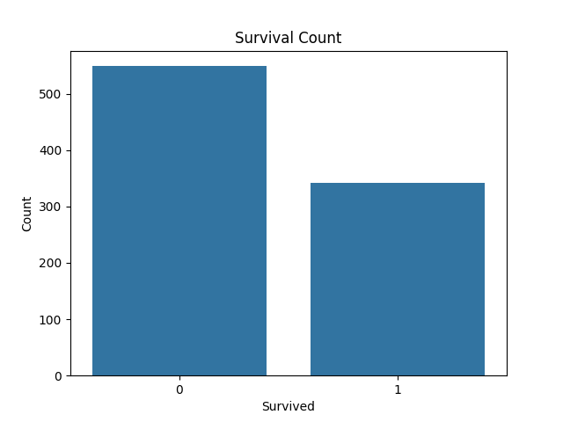
Survival by Gender
- Females have higher survival rate than males
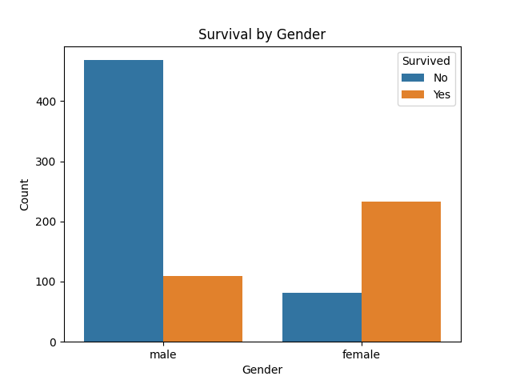

Age Distribution Graph
- Shows common age groups of passengers
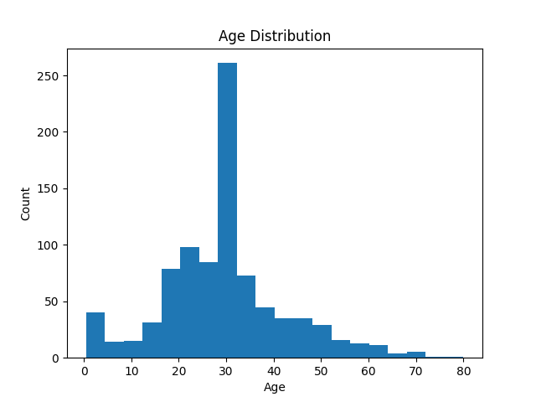
Fare Distribution Graph
- Most passengers paid low fares
- Few passengers paid very high fares
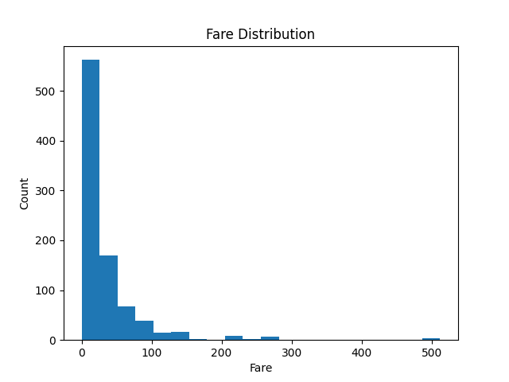

Heatmap Graph
- Shows relation between features (age, fare, class, survival)
- Helps in understanding data patterns
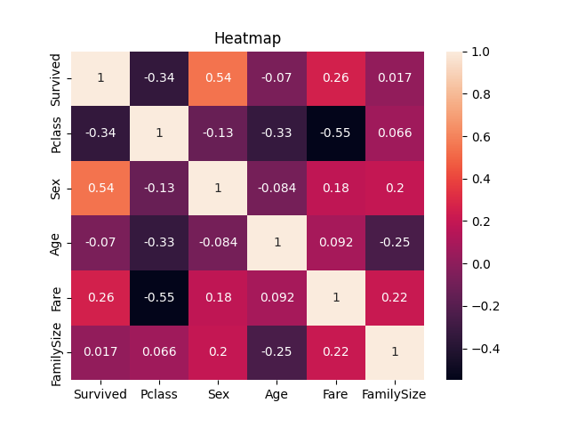

🔹 Conclusion
- This project explains the full data science process:
  - Data cleaning
  - Visualization
  - Feature engineering
  - Model building
  - Evaluation
- Machine learning can be used to predict real-world outcomes effectively

